Low Emission Bus Testing

Guidance for test houses

Objective
The new Low Emission Bus test process has been designed in collaboration with industry, operators and government to provide a robust comparison of the operating performance (energy consumption and GHG impact) of all low carbon buses and to allow government support and operator information to be given.

Introduction
In support of the new DfT/OLEV Low Emission Bus (LEB) Scheme, LowCVP has produced guidance notes for testing the range of technologies expected.
These notes should be read in conjunction with the detailed testing requirements previously published for LCEB testing and accreditation and available on the LowCVP website.
Please contact LowCVP directly if you have a technology not considered here or wish to gain further clarity on the test process detail.
All manufacturers are encouraged to test to the new LUB test cycle and any current requirement for BSOG LCEB validation will be extracted from this data.
Key points:

Gas buses
Buses powered by gas or biomethane should be tested over the complete LUB cycle assuming they are run on grid-sourced CNG. Biomethane suppliers should provide evidence of their fuel credentials to LowCVP for the final certificate to be published

Electric buses
Buses powered by electricity only, should be tested over the complete LUB cycle assuming they are run on grid-sourced electricity. The total energy used should be measured and a full charge completed with grid energy measured to establish the charging efficiency.
Electric Range should also be measured by the test facility.

Plug-in hybrid buses
Manufacturers should discuss the operating characteristic for their plug-in vehicles with the test house and / or LowCVP to ensure the optimum test process is adopted.

Test Cycle: - New LUB (LowCVP UK Bus) cycle
The LUB (LowCVP UK Bus) cycle will be used for all tests. This was developed from the previous MLTB (Millbrook London Transport Bus Cycle) used for all previous UK Bus schemes, and the addition of a “rural” phase of operation on the front of the test to represent typical UK driving operation.
Warm-up of the vehicle will be done using the rural cycle phase to ensure the vehicle is stabilised prior to test. Manufacturers and test houses can determine any additional warm-up requirements but the final element should be the rural phase.
For plug-in vehicles, all battery energy consumed must be recorded (to enable accurate charging and net energy calculations). Vehicles may be run with no warm-up between tests if requested by the manufacturer.

Test weight: - 50% of seated capacity @ 68kg per passenger
The test weight for the vehicle is determined by using the unladen kerb weight (which must be declared and will be confirmed by the test facility) and adding 50% of the seated passenger capacity using a nominal 68kg per passenger. This was selected as consistent with bus regulations and TfL approach.
Note: To allow some scope for specification variation, it is proposed that a vehicle can be tested at a specified seating configuration and that this test will cover variation of +/- 5 seats either way; i.e. a bus with alternative seating from 40 to 50 seats would be tested at a single figure of 45 seats.
Note: Seating capacity cannot be less than 50% of total passenger capacity.

Dynamometer Setting: – Coastdown test required
Chassis dynamometers should be set using road load data from coastdown testing. LowCVP recommends that all LEB vehicles undergo new coastdowns as the data from previous work may not cover the higher speed of the rural cycle which could adversely affect the results.

Test fuel: – Assume grid or conventional fuel used for test
Vehicles should be tested on market available fuel unless specifically requested to use a bespoke fuel, in which case a sample of fuel will be taken and stored by the test facility.
Gas powered vehicles should declare the specification of gas being used for test and the recent fill locations.
The specification of fuel used for test (and for calculating fuel consumption figures) will be stated by the test facility.

Non plug-in vehicles: - 3 repeat tests to give average result
Non plug-in vehicles will be tested over the LUB cycle a minimum of 3 times to give statistical confidence in the results obtained. Hybrid systems will be monitored and net energy change corrected as per the procedure defined in the detailed testing documents.

Zero emission buses: – Range and energy consumption measurement required
Buses fueled exclusively with electricity or Hydrogen will be testing over the LUB cycle to give accurate energy consumption over the complete cycle. A minimum of 3 test cycles will be conducted. EV range will be determined either through repeat test cycles to depletion or via interpolation of SOC data and manufacturer declared battery operating characteristics. DfT retains the option to formally verify EV range at its discretion.

Zero Emission Capable (ZEC) Buses
A bus which has a zero emission operating mode and can complete the full inner London phase of the test (2.5km) in this mode without additional charging can be defined as zero emission capable. If the ZE mode is limited operation (i.e. speed limited) the full cycle should be run and modal emissions and energy data recorded for subsequent analysis.

Zero emission range: - Minimum 2.5km
To determine the ZE range of a ZEC bus, the vehicle will be testing over the LUB cycle (or phases thereof) from a fully charged condition until either 4 LUB cycles have been travelled or the battery is depleted and the conventional engine starts.
Battery SOC and energy flow will be measured on all ZEC buses and may be used to determine ZE range if beyond 25km.

Advanced ZEC hybrid buses (non plug-in)
Vehicles with advanced ZE capabilities which operate as hybrids (no off board charging) may be controlled to operate in ZE mode for a specific portion of the cycle. Multiple tests should be run with energy measurement and correction for zero net energy change may be required.

Determination of WTW GHG and energy for plug-in hybrid vehicles
Plug-in vehicles will be tested in two modes.
1. Engine mode (depleted battery) 2. ZE mode (from full battery). If the ZE mode is limited operation (i.e. speed limited) the full cycle should be run and modal emission and energy data recorded for subsequent analysis.
The ZE mode will be run over a maximum of 4 repeated LUB cycles. If the vehicle is able to complete this in ZE mode without charging it will be assumed to operate as a fully zero emission bus.

Energy to recharge any battery should be determined as for a pure EV bus.
The standard journey (distance between charges) used to calculate GHG performance, will be assumed to be 4 LUB cycles (66km). If this is not appropriate, manufacturers should provide evidence of specific operating and charging regimes for DfT/LowCVP consideration.

Setting the LEB target:

Correlating MLTB to LUB cycle – Factor to use 89%
From 7 diesel vehicles tested (hybrid and conventional) LUB gives CO2 levels consistently at 89% of MLTB.

Establishing the Euro V conventional baseline – ‘Best’ practice line
Using LowCVP and TfL test data, appropriate compromise line identified
Note: Some “conventional” vehicles had mild levels of hybrid and were deemed too low. Several larger vehicles are heavy single deck and deemed too high.
LowCVP took a view that new baseline could not exceed old Euro III assumed baseline.
Compromise approach based on previous data and target lines together with LEB objectives.

Baseline established which reflects greater progress made on smaller single deck than on double deck/large single.

Euro V baseline WTW CO₂ = 480 + 9.42 x Pax

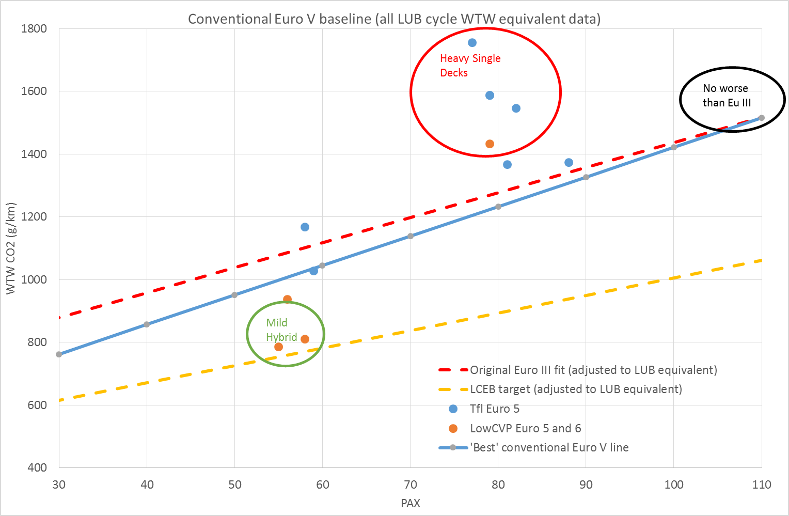

LEB target defined as 15% better than diesel conventional.

LEB target line WTW CO₂ = 408 + 8.00 x Pax

All hybrids tested meet LEB status, with clear margin, however several were at prototype stage and test mass has been revised slightly from pilot testing, so some movement is expected for certification.

